Python Internship Tasks Report
Name: Niveditha
Course: B.Tech CSE
Domain: Python Development Internship
TASK 2
API Integration & JSON Handling
Objective
To learn how to fetch and process data from APIs.
Description
Used Python requests library to fetch JSON data and display selected information.
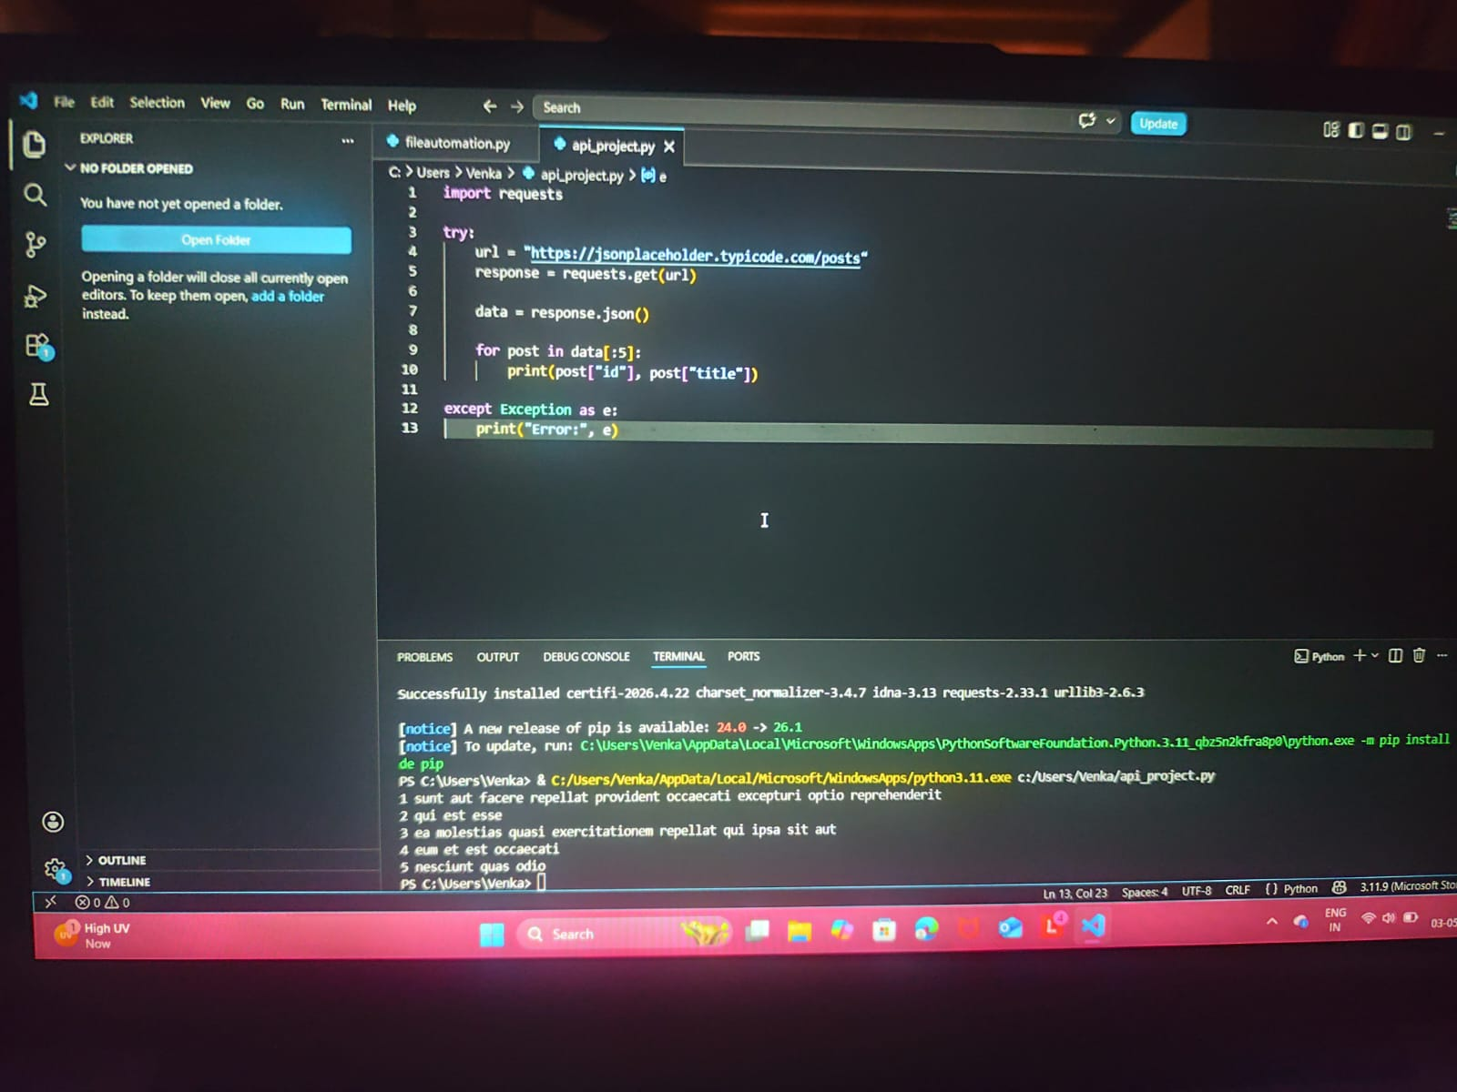
Output
Displayed first 5 posts from API with ID and title.

